AP L2 SM4 – UEL Anglais Listening practice

Please don’t turn the page until told to do so.

Pop Forever: Tom Wesselmann by Tomokazu Matsuyama

1) Where does Tomokazu Matsuyama work now?

2) Where, when and how did he discover Tom Wesselmann?

3) What struck him about Wesselmann’s work?

4) What objects did Wesselmann include in his work?

5) What question did it trigger for Matsuyama?

6) What did it represent to him?

7) What element did Matsuyama incorporate in his own work?

8) In which context did he come into contact with these influences?

9) Was this a conscious artistic process?

10) What was the key thematic element in this artistic research?

11) What other influence played a part?

12) How does he categorize his paintings?

13) What do they represent?

14) How are these two aspects connected?

15) What did he think would happen after some time, and what actually happened?

Transcript: Pop Forever: Tom Wesselmann by Tomokazu Matsuyama

Listen and read at the same time, and ask yourself:
1) What easy words did I miss?
2) Is there anything that I still don’t understand?
3) Is there any sentence or part of a sentence that I could use later?

Hi, my name is Tomokazu Matsuyama. Welcome to my studio in Brooklyn.

The earlier influence of Tom Wesselmann to my practice is that I think it goes back to when I came to New York, and for the first time I think seeing his work in person. The work was a painting but it was somewhat sculptural. It included real objects such as toasters, refrigerators, and I also remember there was a curtain, and perhaps a Coca-Cola bottle as well. And then there was a figure. And when I looked at that it was like “well is this a painting?”. But there was the glamor of actually experiencing this kind of American dynamism, and it kind of took away everything of what a painting was. It felt vintage because it was (from the) 60s, and from the 70s. And pop art includes so many things that represented that time and era of the world when America's economic impact was so grand, and it was so glamorous and so sexy it really envisioned what we imagined of the future and what it represented.

But that kind of connection between where I'm from and where I'm now and me becoming, wanting to be an artist, it felt like I found a connection. I've created shaped canvases for some years now, and there's a great influence from Wesselmann and other peers that created those works and made a huge statement. I remember coming to New York and going to modern art museums and contemporary art museums and seeing the postwar artists where they made these works that connect painting and sculpture altogether. And while I was heavily influenced by it, I wanted to find my own connection with this work, and I didn't know why it had an impact on me.

After creating these works over years I've recognized there was an interest in vacancy, and not necessarily do my shaped canvases have a specific meaning like the smoking series or Wesselmann's nude series. They came from these organic forms of ceramic ware and how traditional artists painted them, and they became a medium of transformation of shape itself. In my fictional landscape painting I paint landscapes of nature, and also interior settings. Overall, they talk about the same thing, because these interior settings or lifestyles that we show in magazines are actually making your private space public. On the other hand we also try to conquer nature to make a civilized world so the cycle of that is very much the same. It's connecting what we like to conquer and dominate, against who we are. And therefore there's no such a thing as culture inside out, because neither is in or out: they're pretty much equal. And I thought I may get fed up with it, but I haven't. It seems like there's endless ideas, so one idea, one artwork, one exhibition navigates to the next, and just it keeps it keeps on going.

Source: https://www.youtube.com/watch?v=T-F4rK3E_j8

References
The Portrait of Juan de Pareja is a painting by Spanish artist Diego Velázquez of the enslaved Juan de Pareja, a notable painter in his own right, who was owned by Velázquez at the time the painting was completed. Velázquez painted the portrait in Rome, while traveling in Italy, in 1650. It is the earliest known portrait of a Spanish man of African descent.[1]  It was the first painting to sell for more than £1,000,000. At the time of the painting's purchase by the Metropolitan Museum of Art in 1970 they considered it "among the most important acquisitions in the Museum's history".[2] The painting is on display at the Metropolitan Museum of Art in New York City. | 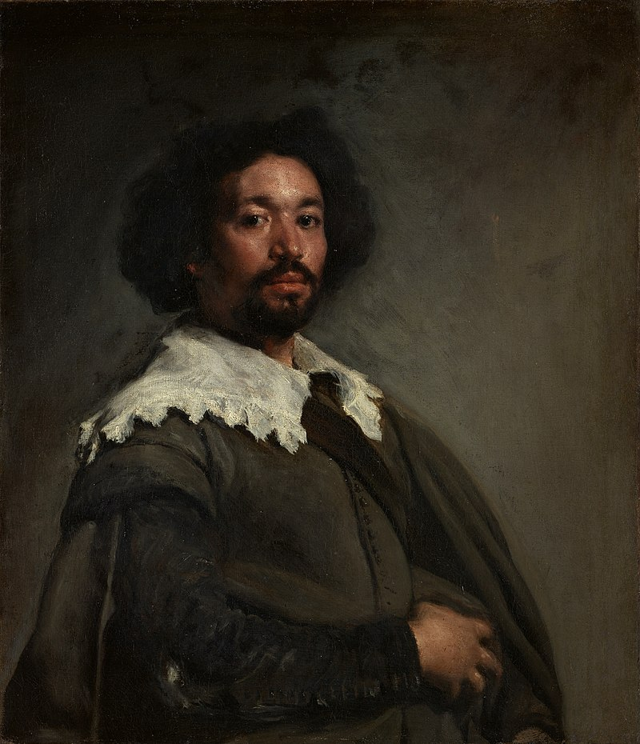
Las Meninas  Spanish for 'The Ladies-in-waiting'[a] pronounced [las meˈninas]) is a 1656 painting in the Museo del Prado in Madrid, by Diego Velázquez, the leading artist of the Spanish Baroque. It has become one of the most widely analyzed works in Western painting for the way its complex and enigmatic composition raises questions about reality and illusion, and for the uncertain relationship it creates between the viewer and the figures depicted. | 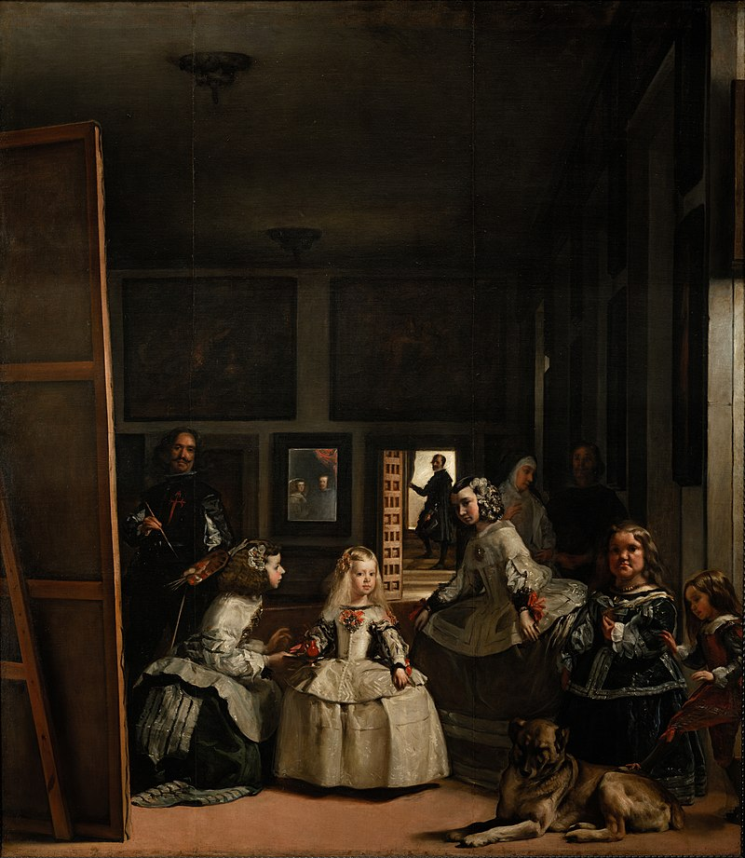
Judith Beheading Holofernes is a painting of the biblical episode by Caravaggio, painted in c. 1598–1599 or 1602,[1] in which the widow Judith stayed with the Assyrian general Holofernes in his tent after a banquet then decapitated him after he passed out drunk. | 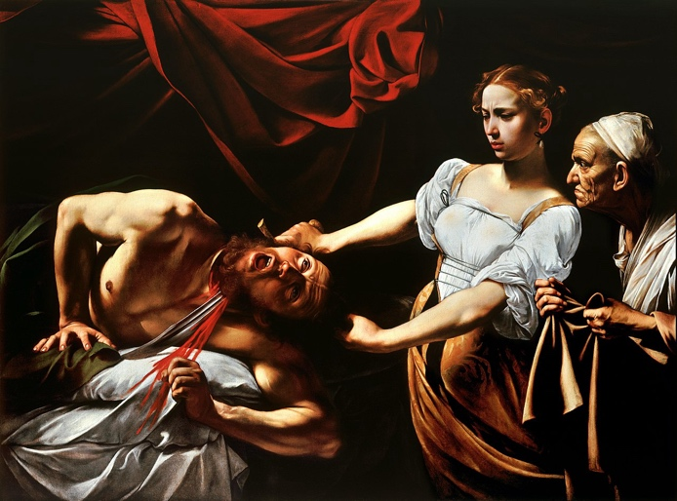
Judith Slaying Holofernes c. 1620, now at the Uffizi Gallery in Florence,[1] is the renowned painting by Baroque artist Artemisia Gentileschi depicting the assassination of Holofernes from the apocryphal Book of Judith. When compared to her earlier interpretation from Naples c. 1612, there are subtle but marked improvements to the composition and detailed elements of the work. These differences display the skill of a cultivated Baroque painter, with the adept use of chiaroscuro and realism to express the violent tension between Judith, Abra, and the dying Holofernes. | 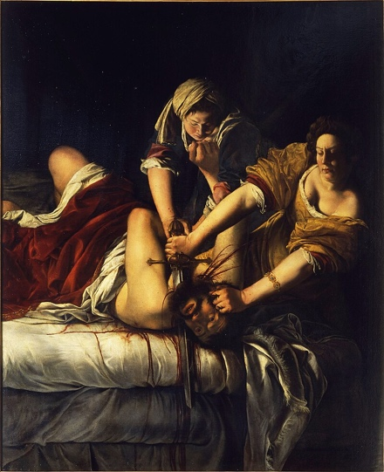
The Burning of the Houses of Lords and Commons, 16th October, 1834 is the title of two oil on canvas paintings by J. M. W. Turner, depicting different views of the fire that broke out at the Houses of Parliament on the evening of 16 October 1834. They are now in the Philadelphia Museum of Art and Cleveland Museum of Art. | 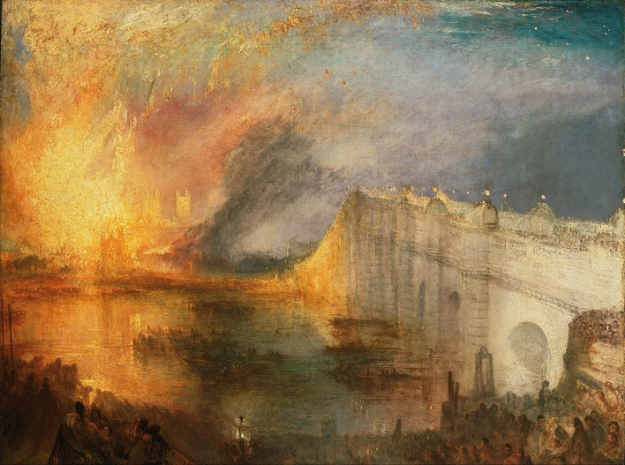

US photographer Tina Barney's penetrating portraits

Source https://www.youtube.com/watch?v=_cVuDw-YbDU

[Music]

a passing glance a wistful gaze a

confident look Tina Barney's portraits

give us a glimpse of the soul of her

subjects she's been honing that singular

perspective from behind her traditional

tripod setup for more than four decades

Barnie's latest Exhibition at the judum

gallery in Paris is called Family Ties a

nod to some of her favorite subjects

children siblings parents often taking

part in the rights and rituals of their

social strata and passing down those

Traditions to the Next

Generation Tina B hello hello how are

you today good thank you now if we look

at your body of work it presents an

almost anthropological study of a

certain demographic within American

Society how would you describe that

group in your own words and why did you

want to zoom in on

them um I would say most of them are

upper upper east side or New England

United States of America and that's

where I live that's where my family's

from that's where my friends are from

and that's why I focused on them because

they were right there and EAS easy for

me to photograph and find there are a

couple of images in this exhibition

graham cracker box uh Sunday New York

Times from the early 1980s which really

represented a turning point in your

career I believe that a lot of attention

uh came to your work what do you think

it was about those images that really

struck people at that time well let's

start off by the fact of the size of the

photograph which was historical in the

history of photography so start with

that the color always and the fact of

the what the camera was using um

created that I think the average person

has no idea a what that camera does and

what it's capable of and also the

composition that that I thought about in

depth uh where I placed the people Where

I Stood

[Music]

Etc working with a large format dark

chamber camera allows her to pull away

somewhat to take a step to one side

away from the scene and to capture it a

bit like an

anthropologist let's put it

simply her photography presents a very

comfortable social class the rich and

that was very striking for many American

critics in the 1980s it was the time of

the neoliberal Revolution Ronald Reagan

TV series like Dallas and Dynasty which

were showing us the sagas of those large

wealthy families it was a time of Brands

and their advertising which also

immortalized the wealthy in their

imagery

so Tina Barney's photos defy

categorization both because the upper

classes was a subject that had very

rarely been dealt with in

photography but also because she seemed

to come at it from a non-critical

stance interior space is something that

often comes up in your work a very

personal use of Interiors can you tell

us how you approach an interior space

well uh I think a lot of that has to do

with number one that my mother was an

interior decorator so I was surrounded

by uh I think extraordinary Interiors my

whole life she also had a special unique

sense of color that was remarked by

people that knew her and so I chose to

photograph interiors that were

interesting to me but a lot of those

Interiors happened to me my my sister

who inherited that same taste of my

mother or friends we see details that

indicate wealth and privilege in your

images the decor or perhaps People's

Clothing but also Behavior gestures can

you tell us about how you use body

language in the pictures you make

sometimes I would tell someone to do

something just to get them moving and

parts of the picture would be directed

by me in a very very simple way and

others I call gifts the accident that

would happen and I didn't take a lot of

pictures frames or sheets of film at

each shoot um but I I I tried to do as

many sheets as I could because most the

ratio of success was is very SL

slim very slim for example can you tell

us a little about the positioning of

these two figures here okay

so um the first the first choice is the

vantage point or Viewpoint and that is

where I stand where I decide to put my

camera which defines uh the Vantage

Point not only technically but also

conceptually and I knew that I wanted uh

this line of the sink to go down the

middle of the frame to bring the eye as

if there was a a line I had drawn to

bring the eye of the viewer towards the

center of the photograph and there there

have been books written about visual

perception that call the power of the

center and I studied that so I had that

line of the sink then I saw the line of

the seam of the mirror so you've got two

very strong lines going to the center of

the image then you have the line going

across of the radiator but then you have

the repetition of the line of the fence

so there are all these structural marks

that excite the eye of the viewer and I

had been doing a lot of reading about

this from Dutch 17th century painters

and on to sort of learn more about it

but then and I call this the sort of the

the icing on the cake is that brush

which I tilted out and the Dutch 17th

century painters did these this kind of

device all the time so I tell Jill to

send that Stan in the

middle and then I tell paully to come

look forward and the gift again is the

reason I go back to my sister over and

over is number one she's my sister but

also the couple of people that I went

back to over and over were oblivious to

the camera and that doesn't happen over

time we see many very American scenes in

this exhibition but you did An important

series Europeans where you photograph a

similar M bouri we'd say in French upper

classes what did You observe about the

major differences between Americans and

Europeans when you were making those

photographs well let's start by saying

that I did not know the people in Europe

before I met them so that's one I would

say a problem number two I realized very

quickly the the second I entered their

houses uh that they were more formal

more reserved more

polite uh and so that changed a whole

lot of things the good part was that I

realized and this took a while to

realize that the tradition the ritual of

having a portrait made in the history of

Europe was such a part of uh their their

lives and their history

that they didn't even question uh what I

was

doing and who I was or anything well the

person that introduced us was very

important of course that they trusted

that friend but that also what was

interesting is they almost posed in an

extraordinarily professional way as if

they had subconsciously maybe imitated

the portraits that were surrounding

their houses that they had lived with

from birth and on and

on class and Status are perhaps elements

that make up Identity or maybe tribalism

and some of that feeds into the culture

wars that we see today America is a

Poise to elect a new president how do

you see the question of uh class or

social status as we look ahead to this

vote I don't think about it cuz I think

uh the world is pretty much of a mess

um and I sort of feel as if uh I've done

my kind of job

I've done all I can do uh it probably

doesn't interest me anymore but where I

live in in this place that I've

photographed most of my

life oh this is probably not strange but

not much has changed

[Music]

sometimes a portrait reveals something

about the sitter or the subject that

they didn't know about themselves or

they hadn't seen or we'd never noticed

you've made some fantastic

self-portraits did you discover things

about yourself in that process well the

reason I I did uh I made self-portraits

is because I realized in the history of

art that self-portraits usually end up

being the most important work that an

art artist makes in photography and I've

said this many times it's more difficult

because of the focus problem is how are

you going to if if you're alone how are

you going to focus your own self and

most of I think the portraits I did is I

was alone I wanted to be alone uh what I

Knew by by making portraits of other

people is that what was important is

number one the eyes and what you tell

the subject to think about or do and I

asked them to think of a very specific

uh narrative or situation because

otherwise you start daydreaming and you

can see when someone's daydreaming and

and getting bored

at a time when people are taking

photographs with their smartphones we

have a very particular uh most people

have a particular relationship with

taking and sharing photographs almost

hyperactive it seems very much at odds

with your very considered approach what

do you you make of this hyper saturated

image era that we seem to live in now

well I think it's pretty horrifying

um I mean I look at Instagram all the

time and it's

fun uh but

uh I don't think there's anything good

about it that's all I can

say and when tools like Photoshop or AI

mean that some images are manipulated or

entirely fabricated do you think we have

the same relationship with photographs

today do they have the same Integrity

can we trust them no of course not no

but you know you're talking about very a

different animal from my photographs to

the general photograph just because of a

not a trust a trust in the

image uh it'll never be the same tinani

thank you very much thank you

