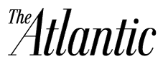

Steal Like an Artist: Creativity in the Age of the Remix

By Maria Popova
Author Austin Kleon explains why it’s OK to steal a few ideas now and then.

Much has been said about the secrets of creativity and where good ideas come from, but most of that wisdom can be lost on young minds just dipping their toes in the vast and tumultuous ocean of self-initiated creation. Some time ago, artist and writer Austin Kleon—one of my favorite thinkers, a keen observer of and participant in the creative economy of the digital age—was invited to give a talk to students, the backbone for which was a list of 10 things he wished he’d heard as a young creator.
So widely did the talk resonate that Kleon decided to deepen and enrich its message in Steal Like an Artist—an intelligent and articulate manifesto for the era of combinatorial creativity and remix culture that’s part 344 Questions, part Everything is a Remix, part The Gift, at once borrowed and entirely original.
The book opens with a timeless T.S. Eliot endorsement of remix culture: “Immature poets imitate; mature poets steal; bad poets deface what they take, and good poets make it into something better, or at least something different.”
Kleon writes in the introduction: “It’s one of my theories that when people give advice, they’re really just talking to themselves in the past.
This book is me talking to a previous version of myself. These are things I’ve learned over almost a decade of trying to figure out how to make art, but a funny thing happened when I started sharing them with others—I realized that they aren’t just for artists. They’re for everyone. These ideas are for everyone who’s trying to inject some creativity into their life and their work. (That should describe all of us.)”
On doing what you love, Kleon urges: “Draw the art you want to see, start the business you want to run, play the music you want to hear, write the books you want to read, build the products you want to use—do the work you want to see done.”
On engineering creative and intellectual stimulation: “There’s an economic theory out there that if you take the incomes of your five closest friends and average them, the resulting number will be pretty close to your own income. I think the same thing is true of ideas. You’re only going to be as good as the stuff you surround yourself with. And on that note, immersing yourself in Steal Like an Artist is as fine an investment in the life of your mind as you can hope to make.”
Source: http://www.theatlantic.com/entertainment/archive/2012/03/steal-like-an-artist-creativity-in-the-age-of-the-remix/254185/
Copyright © 2014 by The Atlantic Monthly Group. All Rights Reserved.

A) Reading
Translate into French:
“Much has been said about the secrets of creativity and where good ideas come from, but most of that wisdom can be lost on young minds just dipping their toes in the vast and tumultuous ocean of self-initiated creation. Some time ago, artist and writer Austin Kleon—one of my favorite thinkers, a keen observer of and participant in the creative economy of the digital age—was invited to give a talk to students, the backbone for which was a list of 10 things he wished he’d heard as a young creator”.

B) Writing (10 pts)
Explain, illustrate and comment on the following principles of creativity in 200-250 words.

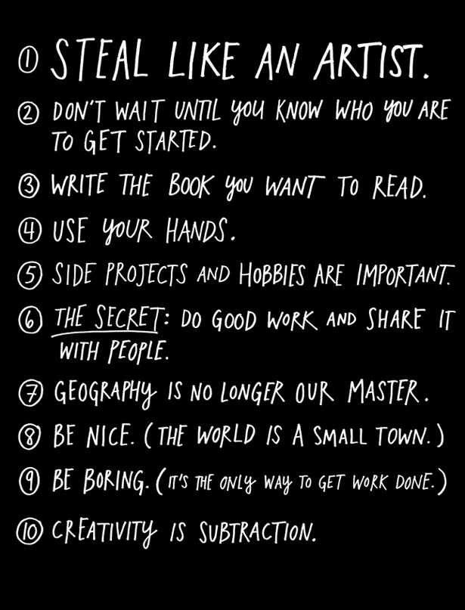
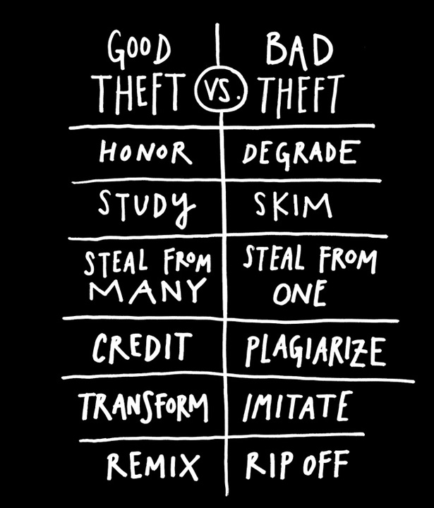

Much has been said about the secrets of creativity and where good ideas come from, but most of that wisdom can be lost on young minds just dipping their toes in the vast and tumultuous ocean of self-initiated creation. Some time ago, artist and writer Austin Kleon—one of my favorite thinkers, a keen observer of and participant in the creative economy of the digital age—was invited to give a talk to students, the backbone for which was a list of 10 things he wished he’d heard as a young creator.

On a dit bien des choses sur les secrets de la créativité et l’origine des bonnes idées, mais l’essentiel de ces conseils peut échapper aux jeunes esprits qui s’aventurent pour la première fois dans les eaux tumultueuses de la création personnelle. Lors d’une conférence prononcée il y a quelques temps à un public étudiant, l’écrivain et artiste Austin Kleon, un observateur attentif et acteur de l’économie de la création à l’ère numérique pour qui j’ai une grande admiration, s’est appuyé sur une liste de dix choses qu’il aurait aimé entendre en tant que jeune créateur.

