Remix artist: Meet street artist-turned-gallery superstar Tomokazu Matsuyama
Source BKMAG - https://www.bkmag.com/2024/08/06/the-art-of-tomokazu-matsuyama-from-the-streets-of-nyc-to-big-shows-in-paris-and-venice/
After 20 years of exploring cultural identity through art, the Japanese-born Brooklyn painter is conquering the world
By Victoria Benzine.

Brooklyn-based artist Tomokazu Matsuyama is standing in the first of five airy chambers in his 8,000 square-foot studio high above Greenpoint, contemplating three monumental paintings that depict fashionable figures in lavish apartments. At first, the works’ clean yet whimsical lines evoke manga. In reality, though, these paintings collage fashionable imagery Matsuyama has copied from magazines, art history and more. The three works he’s standing before will head to Paris soon for a show Fondation Louis Vuitton is hosting around Pop Artist Tom Wesselman.
“My interest is to define cultural identity,” Matsuyama says, contemplating the paintings’ vibrant, varied iconography. It’s only getting more fluid, more complex.” His excitement regarding globalization feels like an antidote to the cynicism of our times. He likens his process to “hip hop DJs cutting, pasting and making hip hop, or house musicians making EDM on computers.”
Buzzing around him are 28 assistants, coordinators and other staff members at work on canvases and computers alike, keeping Matsuyama’s many projects moving. In addition to fine art exhibitions, Matsuyama also creates public artworks and participates in brand collaborations. He currently has a show titled “Mythologiques” on view in Venice, adjacent to but not part of the world’s premier art biennial, through November. He has sculptures and murals from Luxembourg to Los Angeles, has designed sets for J-Pop act Yuzu, and recently ended a year-long turf war on Manhattan’s storied Bowery Mural Wall. After decades at work, his market is taking off, too.
All this for an artist who taught himself how to paint, whose childhood (and childhood identity) were split between Southern California and his birthplace in Gifu, Japan. Matsuyama moved to New York in 2002 at 25 to study graphic design at Pratt Institute after an injury ended his semi-professional snowboarding career. He parlayed his bachelor’s in economics into art.
“You can be creative, but you have a steady job,” Matsuyama says of graphic design, which has taught him how to approach images like a science. “The way it’s creative thinking and problem solving really allowed me to be very creative, and has been a big impact.”
Matsuyama lived in Bushwick while at Pratt, but moved to Greenpoint, where he taught himself how to paint, after getting robbed one too many times. Steeped in the remix culture of the 1990s, he started sampling imagery from magazines, museums, and the streets into maximalist compositions that mimic the way we use pop culture and social media to build identities today.
Early on, he showed his work in local cafes, and started painting murals in a style evoking Takashi Murakami’s “superflat” movement in its meticulousness, which has since become ubiquitous in public art. Then, in the 2010s, street art exploded. Matsuyama’s bold but delicate style stood apart from the work of his famous friends like KAWS, in part, due to his upbringing.
While Matsuyama has said that he felt like an American kid growing up, the artist retained his Japanese sensibilities as a young New Yorker, in an era before iPhones. “Going to the newsstand was just as exciting as going to the MoMA or the Met, because you got to understand cutting edge, up-to-date culture,” he says, positioned in front of “Serenity Exhale Protection,” one of the three works bound for Paris, holding a folder stuffed with printouts of the painting’s references.
Matsuyama was shocked to see celebrity’ homes in Elle Decor. “I come from Japan, where the country is still very reserved,” he says. Welcoming photographers behind closed doors seemed awfully intimate. “The celebrities are getting bare naked,” he thought. “I was very taken away.”
Matsuyama pulls a copy of an Architectural Digest spread from his folder. Its regal red couch, chair, and table match the furnishings in “Serenity Exhale Protection.” He’s cooled down the digs by painting the walls, instead, with a baby blue floral pattern by textile designer William Morris. Elsewhere, he’s turned the temperature up a notch, by substituting the staid painting behind the couch in the original photograph with late Renaissance painter Artemisia Gentilleschi’s “Judith Beheading Holofernes’,” a violent feminist artwork about class struggle that resonates with his experiences as a minority. Figs and other fruits lying about reference 17th century Dutch painters — and, tucked below, there’s a playful feline in the Japanese “drunken cat” style.
Doing away with hierarchies of high and low culture, Matsuyama comingles a crumpled Starburst rapper and an empty can of Colt 45 with triumphs of art and design in “Silence Wind Flower Believe,” another work in the Paris trio. Most of his figures are taken from fashion spreads. He dresses them in timeless garments enlivened by ornate, often historic, patterns.
In “Safety Retrospective,” the third work in the series, a girl crouches defiantly on a couch in a baroque living room, hanging out with two other friends. The edgy scene features a turntable, an ashtray with a smoldering cigarette in it, and a blaze in the fireplace — which actually resembles the Romantic painter J.M.W. Turner’s painting “The Burning of the Houses of Lords and Commons, 16th October, 1834.” And, in a nod to the Paris retrospective where this particular artwork is heading, Matsuyama has replaced the Wesselman painting pictured in the original interior with a flag by the political, provocative artist David Hammons.
Matsuyama’s studio can only produce 30 paintings like these a year, so he’s intentional with his time. Gallery and museum shows are nice, but they can be elitist. While cutting his teeth as a public artist, Matsuyama learned to value direct dialogue with real people — community members and smaller collectors.
“You become part of art history, every artist wants that,” Matsuyama said of museum shows. “But we also have to make sure that you have a dialogue with the community that you live with.”
Still, Matsuyama’s most impressive public artwork of late is one of the few he’s done illegally. Goldman Global Arts first had him paint the Bowery Mural Wall in 2019. Goldman typically asks a few lucky artists to paint their wall each year. It’s the ultimate feather in a street artist’s cap.
In 2022, Goldman invited LA-based artist David Flores to paint the wall. Some of NYC’s more combative graffiti writers made it clear they didn’t like the out-of-towner’s style by repeatedly bombing his mural. The situation got so out of hand that Goldman relinquished control of the wall for about a year — until Matsuyama got involved last fall. He designed 33 tiled portraits depicting notable New Yorkers into a work titled “From the streets of New York to shows in Paris and Venice: The art of Tomokazu Matsuyama,” then had it printed on vinyl for an easy installation, which his team carried out in under two days — unsanctioned. At first, Goldman Global Arts was apprehensive, but when they saw that civilians and graffiti writers alike enjoyed Matsuyama’s addition, they made his artwork official. The piece is still riding today.
Meanwhile, of Matsuyama’s 24 global solo shows so far, “Mythologiques” — organized by Turkey’s Contemporary Istanbul Foundation following his participation in 2022’s Istanbul Biennale — might be his most mesmerizing yet. Five larger-than-life paintings encircle viewers, including an intricate interior, a jungle exterior, a car traversing a psychedelic landscape, and a salon painting with dense rows of replica artworks in it. A checkered starburst radiates from the floor, enhancing the hypnotic effect: As humanity grows more interconnected and complicated, people must learn to see each other as humans above all else.
And where else could such a movement, and such a show — staged in Italy and hosted by Turkey, with a Swiss curator and a Japanese-American artist — take shape, but in Brooklyn?

A) Questions as you read (quote from the text to justify).

- What other artistic practice does Matsuyama compare his approach with?

- Is Matsuyama a solitary artist?

- Is Matsuyama a successful artist?

- Was Matsuyama meant to be an artist? What did he study? What did he learn?

- What sources did Matsuyama use for his works?

- Does Matsuyama consider that exhibitions are the ultimate achievement for an artist?

- Explain the phrase: “the ultimate feather in a street artist’s cap” (l.68)

- Explain the sentence: “The piece is still riding today.” (l.77)

B) Vocabulary
1) Try to replace the following terms from the text (left) with a synonym from the bank (right):
- airy (l.1) | - immerse
- whimsical (l.3) | - reference
- antidote (l.9) | - omnipresent
- ubiquitous (l.30) | - time
- era (l.34) | - captivating
- comingle (l.49) | - complex
- edgy (l.54) | - cure
- relinquish (l.71) | - audacious
- intricate (l.81) | - tense
- lavish (l.3) | - energetic
- vibrant (l.7) | - old-fashioned
- steep (l.26) | - odd
- bold (l.31) | - spacious
- staid (l.44) | - luxurious
- garment (l.52) | - piece of clothing
- nod (l.57) | - abandon
- mesmerizing (l.80) | - merge

2) What word category (noun, adjective, verb, adverb) are the following terms? Try to give a plausible translation without checking a dictionary.
collage (l.4) / act (l.15) / storied (l.16) / parlayed (l.21) / mimic (l.27) / upbringing (l.32) / awfully (l.39) /spread (l.41, 51) / match (l.42) / digs (l.42) / struggle (l.46) / unsanctioned (l.75)

C) Critical Thinking & Broader Discussion

In groups of 4 to 5, pick one of the following topics and discuss for about 20 minutes. Please use specific examples (you can search online for more of his works).
Then prepare a summary of the main ideas to share with other groups.

- What does Matsuyama’s work suggest about globalization and the blending of cultural identities?
- How does Matsuyama challenge traditional hierarchies of high and low culture?
- What does Matsuyama’s work reveal about the tension between tradition and modernity?
- In what ways does Matsuyama’s work reflect the influence of digital culture and social media on contemporary visual storytelling?
- Can Matsuyama’s approach be seen as a critique of consumerism, or does it embrace it?

Charting the Legacy of Pop Art in the Work of Tomokazu Matsuyama

Japanese-born and U.S.-based, Matsuyama offers a unique perspective, highlighting the pervasive influence of American commercial culture worldwide while drawing parallels with Japanese culture. His work examines how these cultural strategies operate within commercial, media, and social media realms, contributing to a global culture that often leans toward homogenization yet thrives on a rich exchange of symbols and elements from diverse backgrounds.
In particular, Matsuyama’s shaped canvases feature densely layered collages that capture the cultural and aesthetic diversity of our global society. The sources for each piece range from traditional art history to contemporary fashion campaigns, along with objects and interiors inspired by popular design magazines. These are often blended with references to Japanese culture, visible in the manga-inspired flatness of his characters and traditional landscape motifs. His art embodies a cultural fluidity that reflects the diasporic experience and the global nature of identity, moving beyond a fixed idea of pop culture. “I was a minority when I got to the U.S., but even in Japan, I was that, as my father was a pastor,” he explained. “Throughout my life, I couldn’t adapt. Now everybody’s trying to adapt to the world. What I’m doing in my work is adapting different influences to reflect us.”
When discussing his connections to Pop Art, Matsuyama noted that if his work is categorized as such, it’s because his palette is colorful and certain elements align with the genre. He also acknowledged the influence of pioneers like Warhol and Wesselmann, the latter of whom played a key role in his early digital collages, which he later translated to shaped canvas. What intrigues him most, however, is that while Japanese culture has traditionally valued fine objects such as historical ceramics or porcelains, Wesselmann and other Pop artists elevated the everyday object to a similar level. “My way of assembling fictional landscapes from everyday items represents a continuation and transformation of Pop Art,” he said. At the same time, Matsuyama layers his work with additional dimensions, incorporating a final dripping of white paint reminiscent of Pollock’s Abstract Expressionism and treating art and cultural history as a vast, global archive—carefully researched, selected and recombined using digital tools before translating them into painting.
At the same time, while Pop artists like Warhol explored the imagination conveyed through media such as TV, magazines and advertisements, Matsuyama engages with a digital archive of our civilization—one that already fuses traditional and historical, contemporary and vernacular, on a global and multicultural scale. He also draws parallels to today’s cultural disorientation, noting that “back then, in the ’70s, America was going through this huge economic growth, and therefore there was a dark side that was coming.” The quest for idols, for points of reference, for something to believe in is what both pop culture and Pop Art ultimately express. “Now we’re going to this last generation stage, like: Where do we fit? What do we belong to?”
In this light, Matsuyama’s art—and indeed, this entire exhibition—can be seen as a celebration of “Pop” as a model for multiculturalism, which has already permeated today’s global popular culture. This model embraces the complex, multifaceted nature of modern popular culture and offers the potential to move beyond the subtle nationalist undertones of the American Dream that Pop Art once exposed, instead fostering a new sense of belonging rooted in shared global identity and an ongoing, cross-border exchange of goods and symbolic meanings they carry.

Elisa Carollo - Extracted from “Charting the Legacy of Pop Art in the Work of Derrick Adams, Mickalene Thomas and Tomokazu Matsuyama” – observer.com
https://observer.com/2024/10/exhibition-review-pop-forever-tom-wesselmann-fondation-louis-vuitton/

More references on Matsuyama

https://www.dailyartmagazine.com/interview-with-tomokazu-matsuyama/

Navigating the Complexities of Identity: Interview with Tomokazu Matsuyama
Ania Kaczynska 8 April 2024

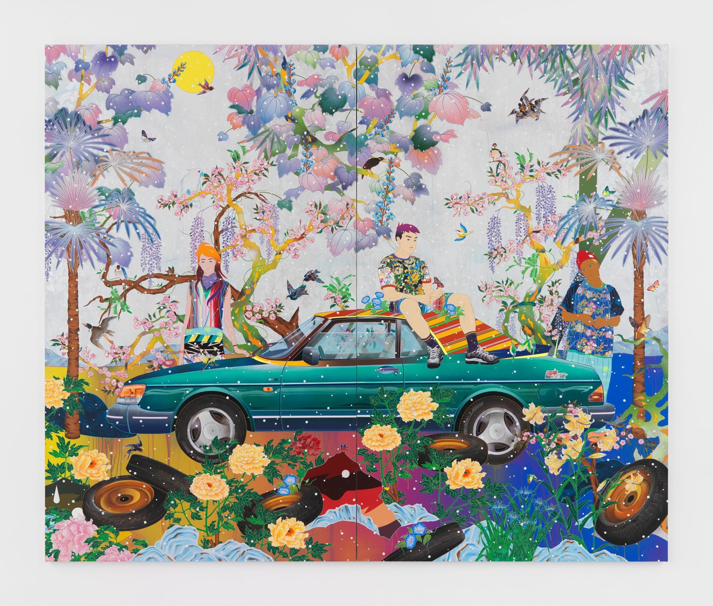
Tomokazu Matsuyama, Winter Song Solitudes, 2023, acrylic and mixed media on canvas ©
Tomokazu Matsuyama. Courtesy of the Artist and Almine Rech. Photo by Melissa Castro Duarte.

Tomokazu Matsuyama is a contemporary New York based Japanese artist who explores his bi-cultural upbringing through his unique artistic style. He combines meticulous artistry with a conceptual depth, examining the complexities of identity in our globalized reality. The artist challenges the audience to question their understanding of cultural homogeneity by exploring the organic disorder present in our everyday social surroundings. We had a chance to talk with Matsuyama on the occasion of his 2023 show Episodes Far From Home at the Almine Rech gallery in London.
In this interview, Matsu discusses his creative process, his approach to combining disparate cultural elements, and the message he hopes to convey through his art. He also reflects on his diasporic identity and the challenges of navigating multiple cultural contexts.
Ania Kaczynska: Could you tell me a little bit more about Episodes Far From Home, your first solo show with Almine Rech in London?
Tomokazu Matsuyama: As a multidisciplinary artist used to creating large-scale sculptures, installations, and murals, the idea of creating a solo exhibition was not an easy one. Packaging myself, a Japanese artist, and this multitude of things that I create and connecting it to the dialogue with Almine Rech, who I have known for years, was a challenge.
What I wanted to showcase in London and in Europe is what I call visual dialect: references and images that bring us all together on an international scale, whether it be traditional culture, contemporary culture, popular culture, or consumer culture. I’m interested in trying to find the dots between them and create a type of chaos that’s more organic and less vocal. There is this notion of awkwardness in it, but also a notion of comfort.

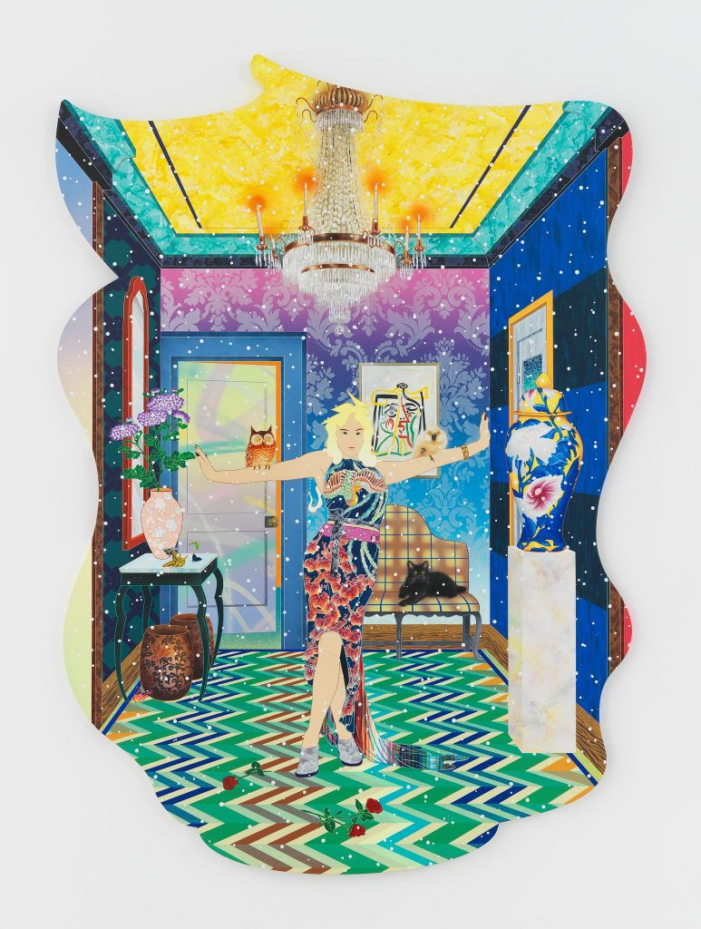
Tomokazu Matsuyama, The Letter Half Awake, 2023 – Acrylic and mixed media on canvas – 269.2 x 194.1 cm, 106 x W76.4 in / © Tomokazu Matsuyama – Courtesy of the Artist and Almine Rech – Photo: Melissa Castro Duarte.
In Episodes Far From Home you’re gonna first encounter a wallpaper. It is referencing a British wallpaper pattern called Tiffany’s Garden, a very traditional motif. I’ve taken that and redrawn it to make it more of a visually saturated, vibrant, artistic installation wallpaper. It’s welcoming the viewers from the outside and reminds them of something very local, even though it’s already translated.
The show features multiple canvases, which are shaped canvases, referring to traditional Japanese and Chinese paintings and Japanese folding panels. However, in some images, the figures are placed in interior settings. Those are referencing something completely different: they are inspired by Western magazines, such as Elle Decor or Architectural Digest.
In my work, consumer culture and popular culture contrast with Zen meditative and Asian visual language.
But it is not to talk about what’s East and what’s West, it’s more about what it means to live in this day and age where information is abundant. My interests lie in finding a connection between then and now, the past and the present, through that contrast.

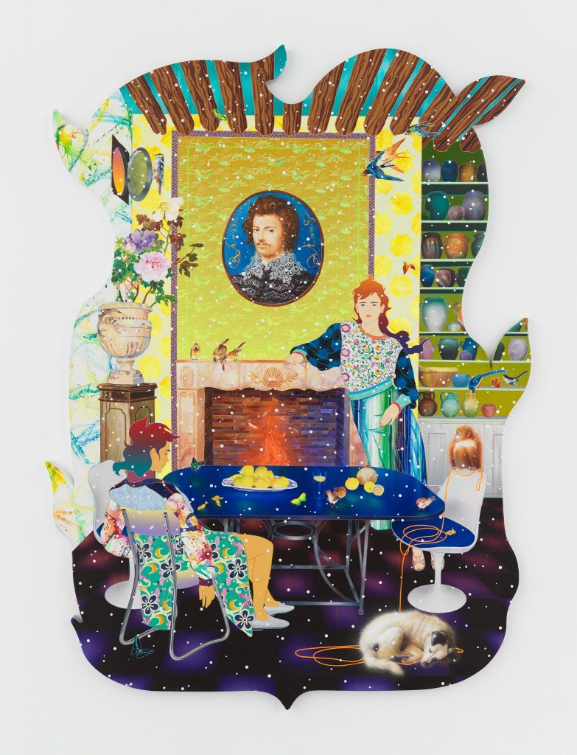
Tomokazu Matsuyama, Winter Song Solitudes, 2023, acrylic and mixed media on canvas © Tomokazu Matsuyama. Courtesy of the Artist and Almine Rech. Photo: Melissa Castro Duarte.
AK: Your artistic practice is often described as cross-cultural, combining both Eastern and Western influences, such as ukiyo-e prints or European Renaissance paintings, and melding their aesthetic principles together. This results in a style that resists any categorization. What does this collision of cultures mean to you?
TM: For me, it’s not just about the clash of cultures, but more about what we can relate to as individuals. I live in America and have also spent time in London, which is a very multicultural city.
America, particularly New York, is a melting pot of cultures and languages, with more than a hundred religions being practiced. This results in a diverse range of values that we all live with and independence being celebrated and encouraged.
However, as a New Yorker, I question what individualism really means. Is it just about being loud and proud about our backgrounds and identities, both positive and negative? I find it challenging to connect with people from different backgrounds because everyone is so unique and there is no norm.
Although the art world is still dominated by white men, at the same time there are many voices and identities being amplified to be accepted. This is where I bring in my reality and try to create something visually elegant and artistic.

AK: And where did this interest to engage with art historical themes emerge in your practice?
TM: My creative motivation is to include art history references, such as Picasso or Japanese paintings, along with consumer and popular culture references, like bags of potato chips and current fashion attire.
I’m interested in how visual information becomes validated as historical and why certain pieces are deemed important and displayed in museums.
I find it subjective and wonder what makes art historical or contextual. As an Asian artist, I don’t try to adapt to what’s considered art history but instead try to find my own connections between different pieces, even if they seem to clash, such as corporate logos and historical paintings. I see no difference in the information we consume in daily life and the pieces displayed in museums.
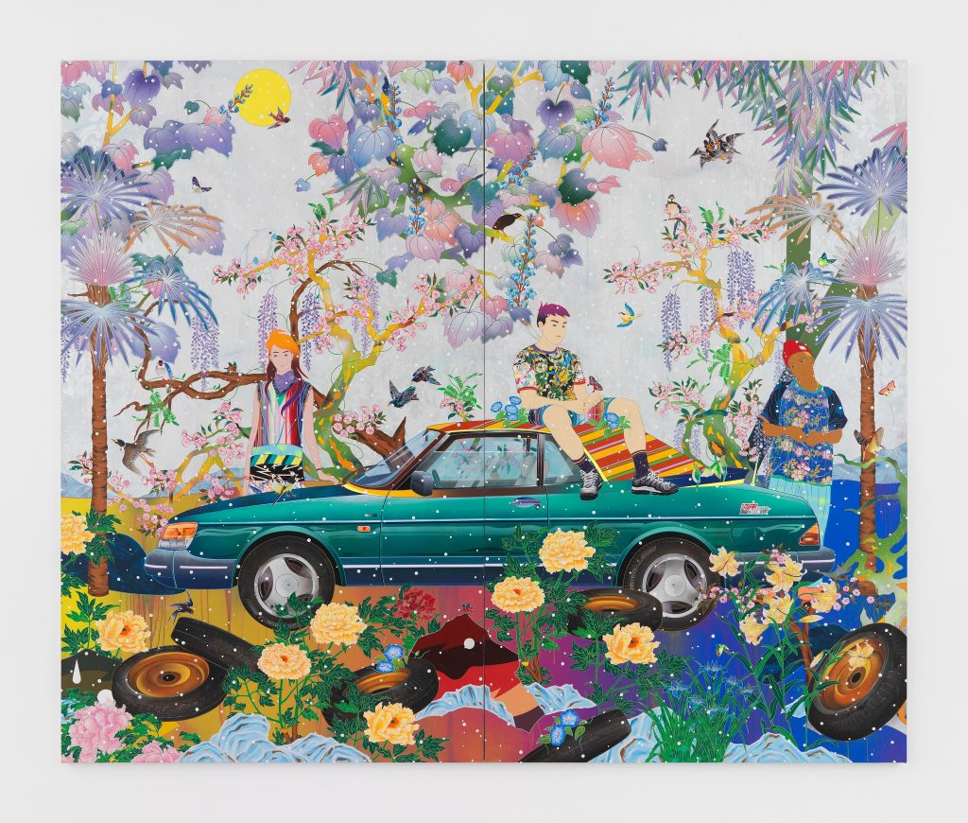
Tomokazu Matsuyama, Winter Song Solitudes, 2023, acrylic and mixed media on canvas © Tomokazu Matsuyama. Courtesy of the Artist and Almine Rech. Photo by Melissa Castro Duarte.

AK: You mentioned popular culture, which has been a recurring theme in arts for a while now. Do you see yourself criticizing it, or do you want it to be deliberately ambiguous?
TM: I don’t like to criticize, but I am aware of what’s critical. Perhaps it’s because of my Asian background and the way I was taught about contemporary art, which built upon American post-war movements and -isms. As the multiculturalism era began, we started to focus on our own identity and history, which unfortunately often spotlighted negativity. Being Asian, I never felt part of Western history; now, anti-Asian hate is ceasing to be invisible, yet I’m hesitant to bring that into my art.
Traditional Asian art often referenced hope and luck, with sculptures of Buddha meant to bring happiness and long life. Asian art was never a propaganda tool but rather a utility object; it was used to depict nature and the four seasons, which became a representation of life, death, reincarnation, and Zen. The West, on the other hand, built history on portrait painting, funded by the aristocracy to idealize themselves and their lifestyle, with Napoleon being a prime example. I appreciate both traditions and follow the historical trends of the West while also incorporating the emotional elements of nature and life that are prominent in Asian art.
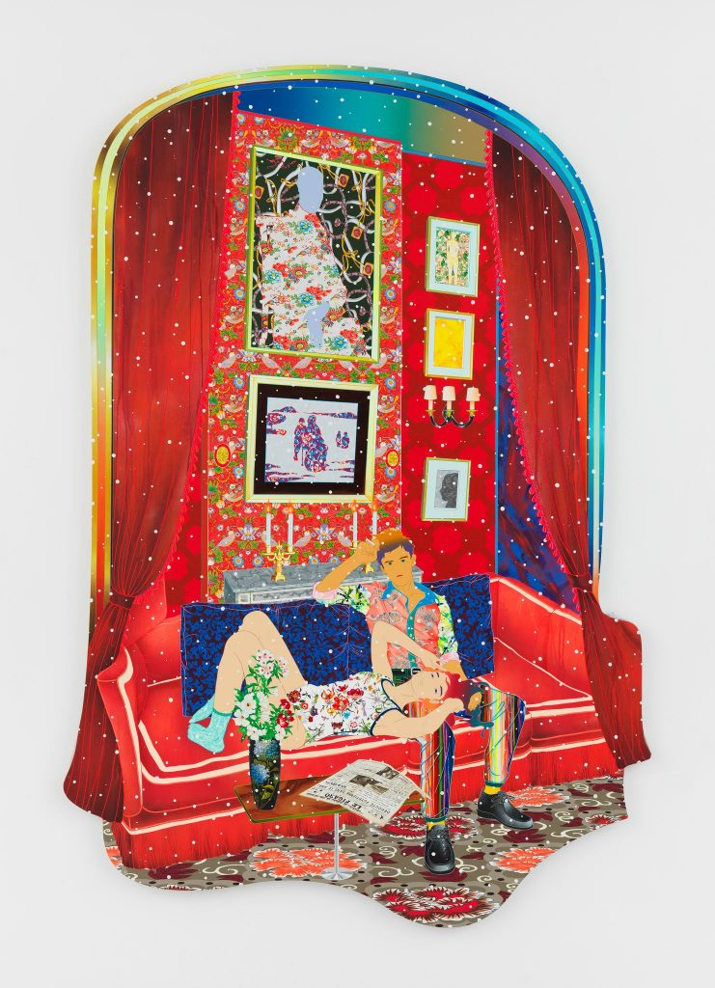
Tomokazu Matsuyama, No Skin Echo Boomed, 2023, acrylic and mixed media on canvas © Tomokazu Matsuyama. Courtesy of the Artist and Almine Rech. Photo: Melissa Castro Duarte.

AK: Evan Moffitt has described the textiles and the use of wallpapers in your work as “camouflage.” Would you say that it is a response to the state of the global art world today in the context of cultural sampling on an international scale?
TM: The world we live in is all about ownership. The battle for who owns what has been fought between identities, politics, countries, and nations. I became interested in patterns and textile designs because they are not linguistic. You can instantly feel a culture when you see something like a phoenix or a dragon. It’s a no-brainer that you associate them with China, and it’s just a fact. Similarly, when you see dark navy and flowers, you can connect them to traditional Japanese culture. However, the earth is a sphere, and as I researched more, I discovered similarities between different cultures. The Silk Road is an excellent example. It started in Egypt, went to China, and then spread across the world. Every culture claims that the information that stayed with them for a few decades or centuries is theirs.
For instance, Japan had a Gingham check, and Scotland is famous for its checkered patterns. In America, it’s associated with a picnic blanket. Each culture has its own overestimation and pride, but interestingly, they imitate each other’s designs too. This realization was intriguing to me, and I started incorporating different patterns, such as William Morris’ or Japanese patterns, intentionally in my paintings. That allowed me to overlay different identities and cultures in one picture as a way to talk about globalism. What is revealed is neither American, English, nor Asian; it’s utopian.
Being an Asian artist in New York, I had to find my own voice and a way to make it reach others. It was almost like camouflaging myself, and my motivation to thrive relates to this subjectively.
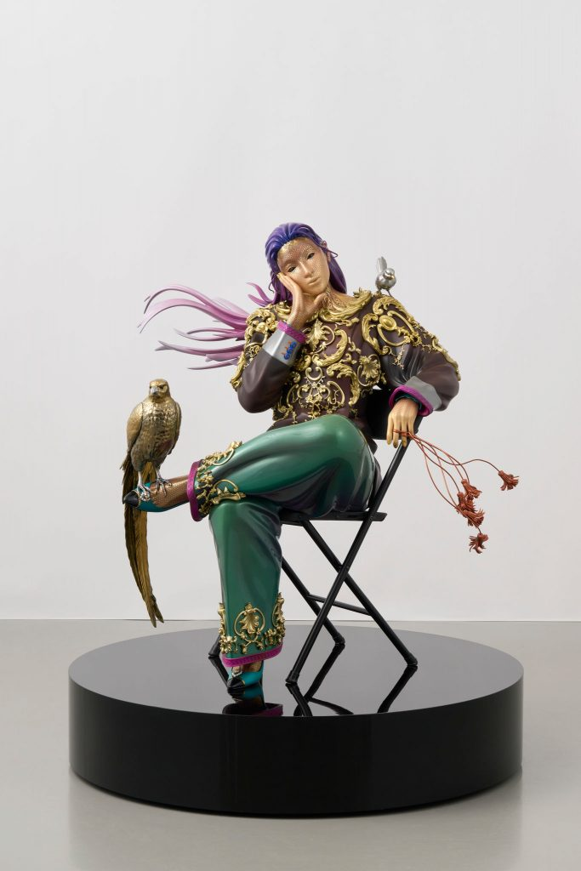
Tomokazu Matsuyama, This Is What It Feels Like, 2023, FRP, wood, steel, epoxy, polyurethane, acrylic, plastic and gold leaf © Tomokazu Matsuyama. Courtesy of the Artist and Almine Rech. Photo: Melissa Castro Duarte.

AK: The gallery space in Episodes Far From Home involves paintings on flat surfaces, but also three-dimensional sculptures. How did you navigate between them in the process of their creation?
TM: Many Japanese artists have created sculptures based on their paintings, but I don’t follow that trend. I was inspired by artists who create sculptures that are conceptually similar to their paintings but still very different, like Lichtenstein, Damien Hirst, and Jeff Koons.
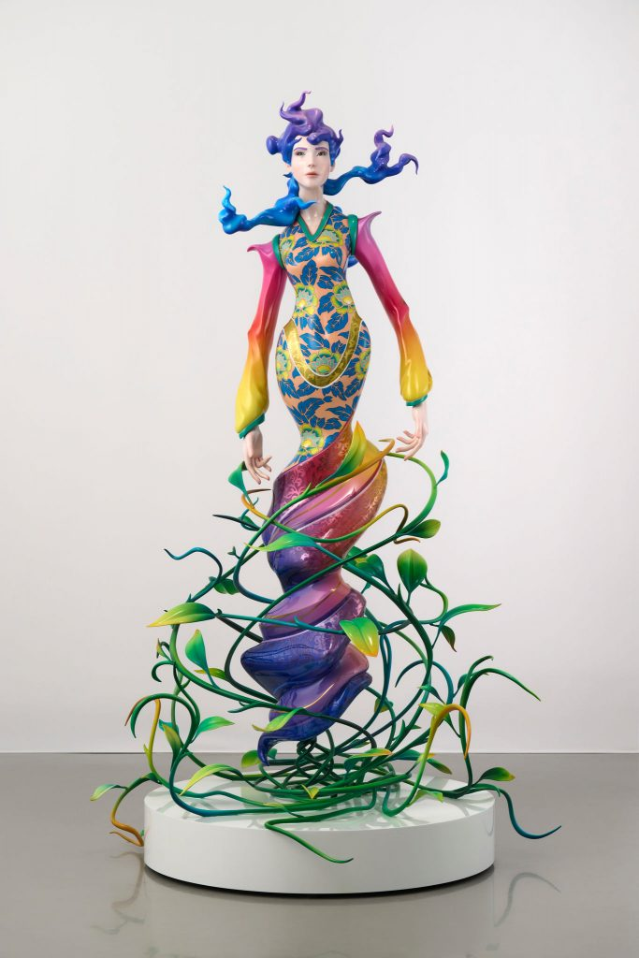
Tomokazu Matsuyama, Mother Other, 2023, FRP, wood, steel, epoxy, polyurethane, and acrylic © Tomokazu Matsuyama. Courtesy of the Artist and Almine Rech. Photo: Melissa Castro Duarte.

When I create outdoor sculptures, my materials are limited, so I’ve been using a lot of stainless steel and mirrored finishes. Although my paintings are known for their vibrant colors, I’ve received feedback that my sculptures lack color. But with my new indoor sculptures, I’ve brought in visual elements from traditional Japanese images and icons, adapting them with gold leaf and other craftsmanship skills that have been used for over a thousand years. For example, the sitting figure in the center of the gallery is adorned with Gothic, Victorian, and Rococo architectural patterns, which are then applied to form a figure with a duality of different decorative arts. I wanted to create something massive for this exhibition, drawing on the design movements of Paris and London, such as Art Deco and Art Nouveau, which were influenced by Japanese culture.

