Large, continental ice sheets in the Northern Hemisphere have grown and retreated many times in the past. We call times with large ice sheets “glacial periods” (or ice ages) and times without large ice sheets “interglacial periods.”
The most recent glacial period occurred between about 120,000 and 11,500 years ago. Since then, Earth has been in an interglacial period called the Holocene. Glacial periods are colder, dustier, and generally drier than interglacial periods. These glacial–interglacial cycles are apparent in many marine and terrestrial paleoclimate records from around the world.
What causes glacial–interglacial cycles?
Variations in Earth’s orbit through time have changed the amount of solar radiation Earth receives in each season. Interglacial periods tend to happen during times of more intense summer solar radiation in the Northern Hemisphere. These glacial–interglacial cycles have waxed and waned throughout the Quaternary Period (the past 2.6 million years). Since the middle Quaternary, glacial–interglacial cycles have had a frequency of about 100,000 years (Lisiecki and Raymo 2005). In the solar radiation time series, cycles of this length (known as “eccentricity”) are present but are weaker than cycles lasting about 23,000 years (which are called “precession of the equinoxes”).
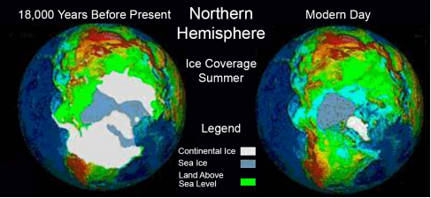
Comparison between summer ice coverage from 18,000 years BP (see, for example, Peltier 1994) and modern day observations. Note that when more water is locked up in ice, more land is exposed due to lower sea levels.

Source: https://www.ncei.noaa.gov/sites/default/files/2021-11/1%20Glacial-Interglacial%20Cycles-Final-OCT%202021.pdf
Wordcount: 234

