50 kW Turbine

Eastern Wind Power's Sky Farm™ 50 kW Vertical Axis Wind Turbine
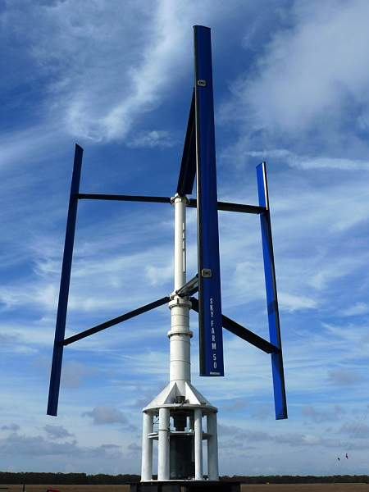
Eastern Wind Power, Inc. has developed the Sky Farm™ 50 kW Vertical Axis Wind Turbine (VAWT) with the strength, stability and versatility to withstand accelerated winds when roof-mounted on high-rise buildings in urban areas or pole mounted in open areas. We also provide a 30 kW electronics system with the same turbine.

Applications
Our umbrella market is Energy Islands: islands or pockets of high energy cost; unpredictable service or no energy infrastructure; yet good wind potential.
i) Ocean islands throughout the globe have extremely high electricity costs, unpredictable or inaccessible service; and constant strong wind, ideal for our pole mounted turbines.
ii) High–rise roof mounted VAWTs provide the most efficient green energy in urban areas where there is the greatest demand and limited space.
iii) Mobile Units (self-contained) for remote Off-Grid locations, particularly to set up a micro-grid for disaster relief applications, as for military base use where fuel is trucked in at premium cost with significant safety hazard.
iv) Developing Countries: Isolated Communities with no energy infrastructure but great need for power to provide basic human needs such as drinking water, lighting and medical facilities.
v) Working farms and remote industrial sites in the US pay a premium for electricity and can become masters of their own energy future using efficient wind energy.
vi) Renewable Energy Portfolio Standards: Turbines can be easily mounted to decommissioned or active power plant chimneys, which provide height and circular geometry favorable to accelerating wind, to help meet REPS requirements for green energy.

Why Vertical Axis Wind Turbines
Our focus has been on Vertical Axis Wind Turbines since they have many advantages over horizontal bladed turbines for roof-top as well as for pole mounted applications. VAWTs are quiet, do not harm avian life, do not have gear boxes and their mechanical issues, and their low profile is more acceptable to community aesthetic considerations. Our standard 54 foot pole brings the total turbine eight to just 80 feet. One of the major advantages of VAWTs is that they can be closely spaced (one diameter apart) conserving valuable land or roof space.

